Challenge: Line Racer

Line Racer Match Procedures
- This will be a double-elimination competition.
- This event will take place on a ~4’x4’ whiteboard placed on a waist-high table, with the course below marked out in 5/8 inch black electrical tape.
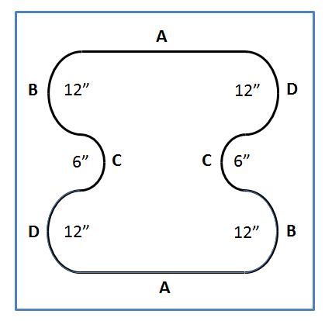
- Racers will start opposite each other at a randomly assigned starting point (A, B, C, or D).
- The race will be two laps.
- One driver will escort the Line Racer as it travels around the table. While escorting the Line Racer, drivers must avoid contact with each other.
- The first Line Racer to cross its original starting position a second time wins. If one Line Racer catches up with its opponent, it will be declared the winner.
- Line Racers must follow the line at all times (no straight runs or fixed turns). A line following algorithm must be used at all times during the race.
- If a Line Racer “loses” the line, the student may pick up the robot and immediately restart it at the last starting point successful crossed (A, B, C or D).
- The wired-remote control may consist of one motor, structural components, and up to two sensors.
- At no time can the Line Racer be moved by pulling on the remote control wires.
Line Racer Specifications
Components: All robots will be constructed only from a single 45544 kit (items as listed on the 45544 inventory) and the following additional allowed items:
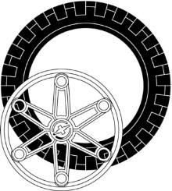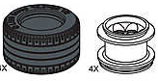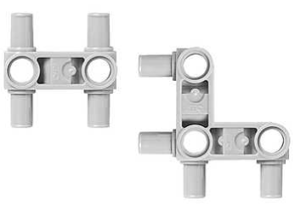

Large or Lawnmower Wheels (up to 2 each) Snap Beams (up to 8 each)
Size: All robots will fit inside a cube 12 inches on a side.
Exceptions: Liner Racers’ wired-remote controls may extend beyond 12 inches from the robot.
Power: All robots will be powered by a Lego rechargeable battery pack.
Design Modifications: Either hardware or software may be modified on the day of competition, provided the robot is ready to compete at its designated time.
Remote Control: Line Racers may use only wired-remote controls. In no case is wireless robot control allowed.

Line-Racer: Grading
Criteria | Points Possible | Points Earned
Engineering Journal - includes a draft of your flowchart program; an initial and final drawing of your robot; at least 4 problems you encountered, and their solutions | 6
Robot meets size requirements | 2
Robot movement is controlled by wired remote | 2
Robot is able to make one complete lap without losing the line (does not need to be traveling fast) | 2
BONUS: Tournament winner! 1st place +2, 2nd place +1 | varies
TOTAL | 12

